Technical Architecture

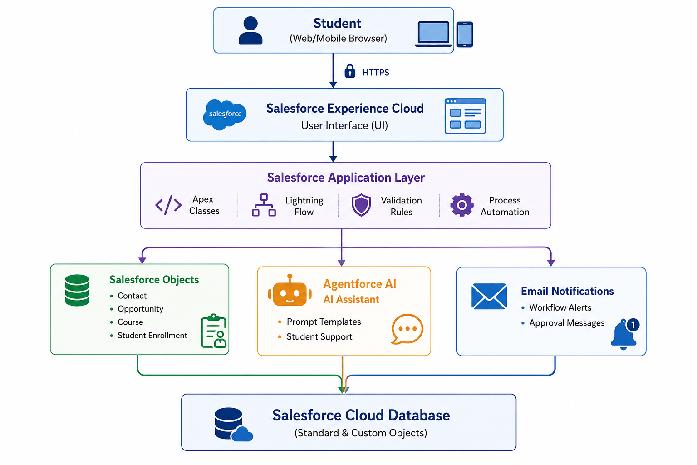

Table-1 : Components & Technologies
S.No | Component | Description | Technology
1 | User Interface | Student and Admission Officer Portal | Salesforce Lightning Experience (LWC), Experience Cloud
2 | Application Logic-1 | Admission workflow and business rules | Apex Classes
3 | Application Logic-2 | Process automation | Salesforce Flow
4 | Application Logic-3 | AI-powered student support and record summarization | Salesforce Agentforce AI, Prompt Builder
5 | Database | Store student, course, and admission records | Salesforce Standard & Custom Objects
6 | Cloud Database | Cloud-hosted CRM database | Salesforce Platform
7 | File Storage | Store student documents and attachments | Salesforce Files
8 | External API-1 | Email notifications and communication | Salesforce Email Services
9 | External API-2 | Integration with external educational services (if required) | Salesforce REST API
10 | Machine Learning Model | AI-generated responses and admission assistance | Salesforce Einstein AI / Agentforce AI
11 | Infrastructure (Server / Cloud) | Cloud deployment | Salesforce Cloud Platform

Table-2 : Application Characteristics
S.No | Characteristics | Description | Technology
1 | Open-Source Frameworks | Web technologies used for custom UI components | HTML, CSS, JavaScript
2 | Security Implementations | User authentication, role-based access, field-level security, secure communication | Salesforce Authentication, Role Hierarchy, Profiles, Permission Sets, HTTPS, OAuth 2.0
3 | Scalable Architecture | Multi-tenant cloud architecture capable of supporting multiple users | Salesforce Multi-Tenant Cloud Architecture
4 | Availability | High availability with automatic backup and disaster recovery | Salesforce Cloud Infrastructure
5 | Performance | Optimized record retrieval, indexed queries, caching, and platform optimization | Salesforce Lightning Platform, SOQL Optimization, Platform Cache

Technology Stack Summary
Layer | Technology
Frontend | Salesforce Lightning Experience, Experience Cloud, HTML, CSS, JavaScript
Backend | Apex Classes, Salesforce Flow
AI | Salesforce Agentforce AI, Prompt Builder, Einstein AI
Database | Salesforce Standard & Custom Objects
Cloud Platform | Salesforce Platform
APIs | Salesforce REST API, Email Services
Security | OAuth 2.0, HTTPS, Role-Based Access Control, Profiles, Permission Sets
Storage | Salesforce Files
Deployment | Salesforce Cloud

